# ADT Week 6 Coding Practice

Name: Atharv Jangam (ajangam)

Semester: Fall 23

Q1.

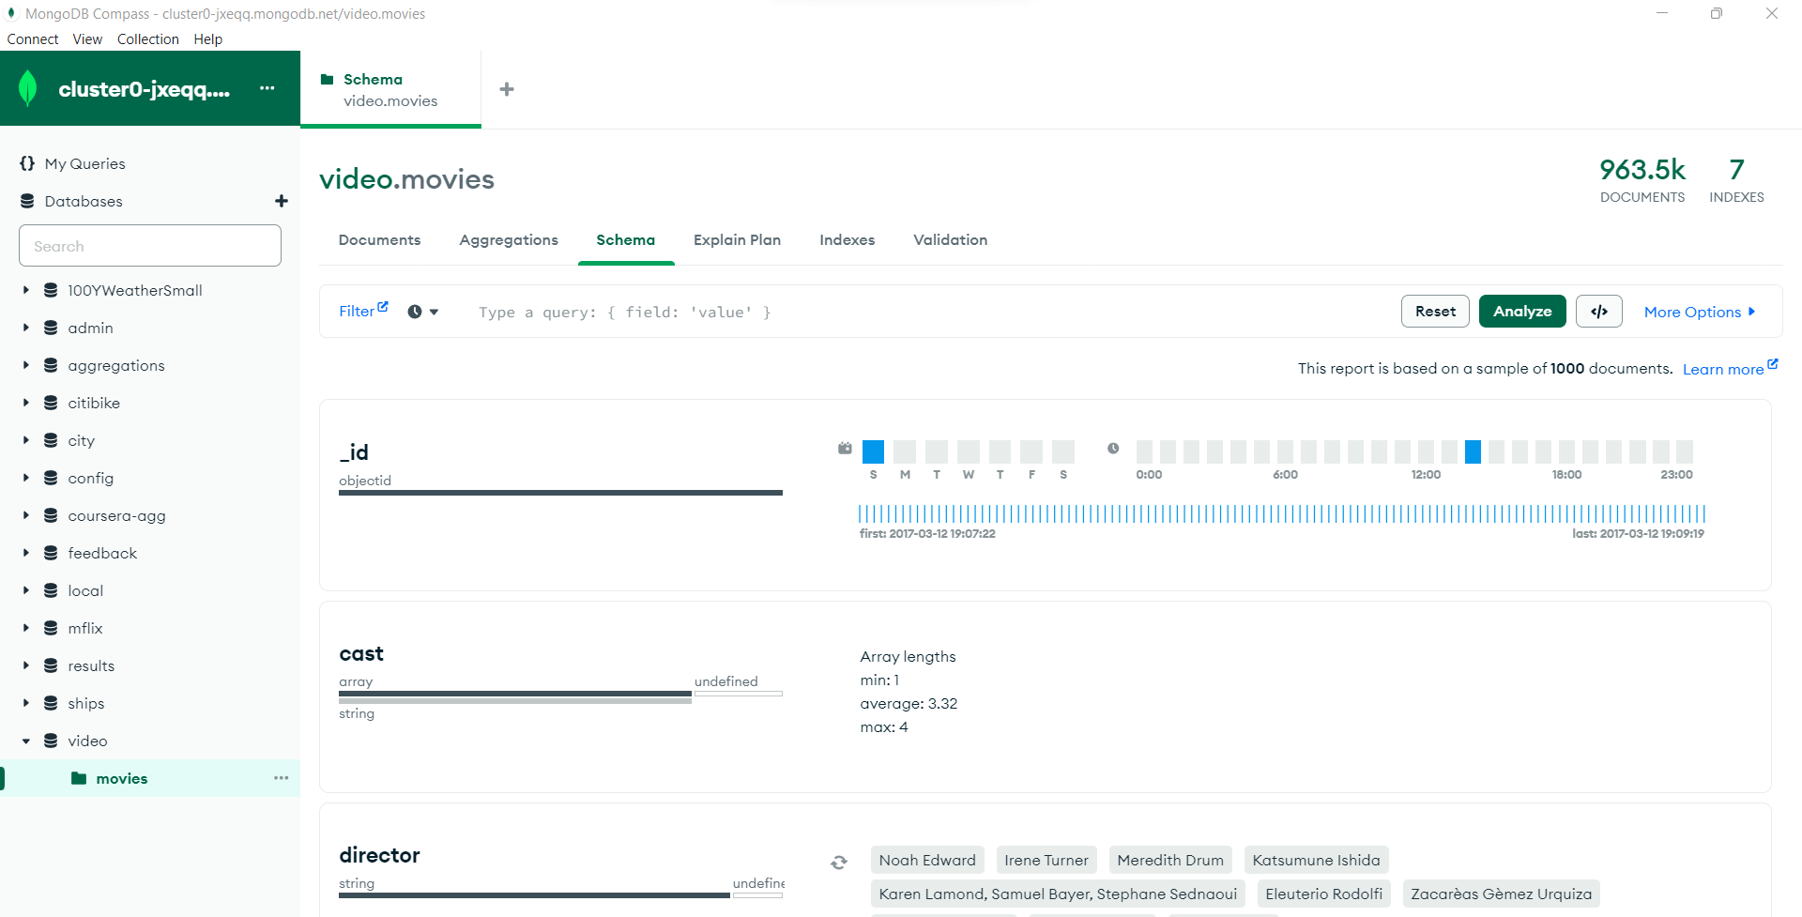

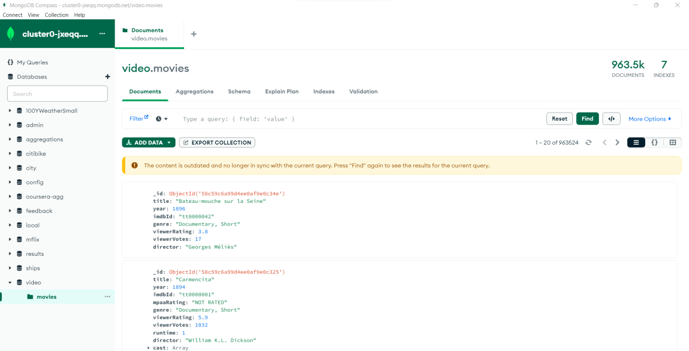

Q2.

Type of field of ‘genre’ – string

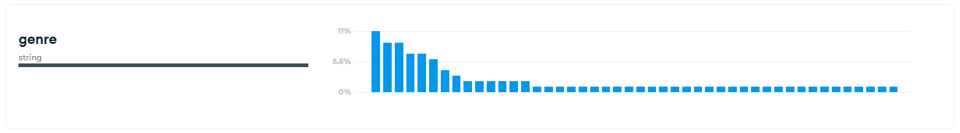

Q3.

